Learning Management System Report

Overview:

The LMS is a software we developed that allows an administrator to manage large number of students by adding/removing/ updating students courses and grades. The LMS also allows students to view their information, courses registered, exam grades, and GPA calculations.

LMS Requirements and Diagrams:

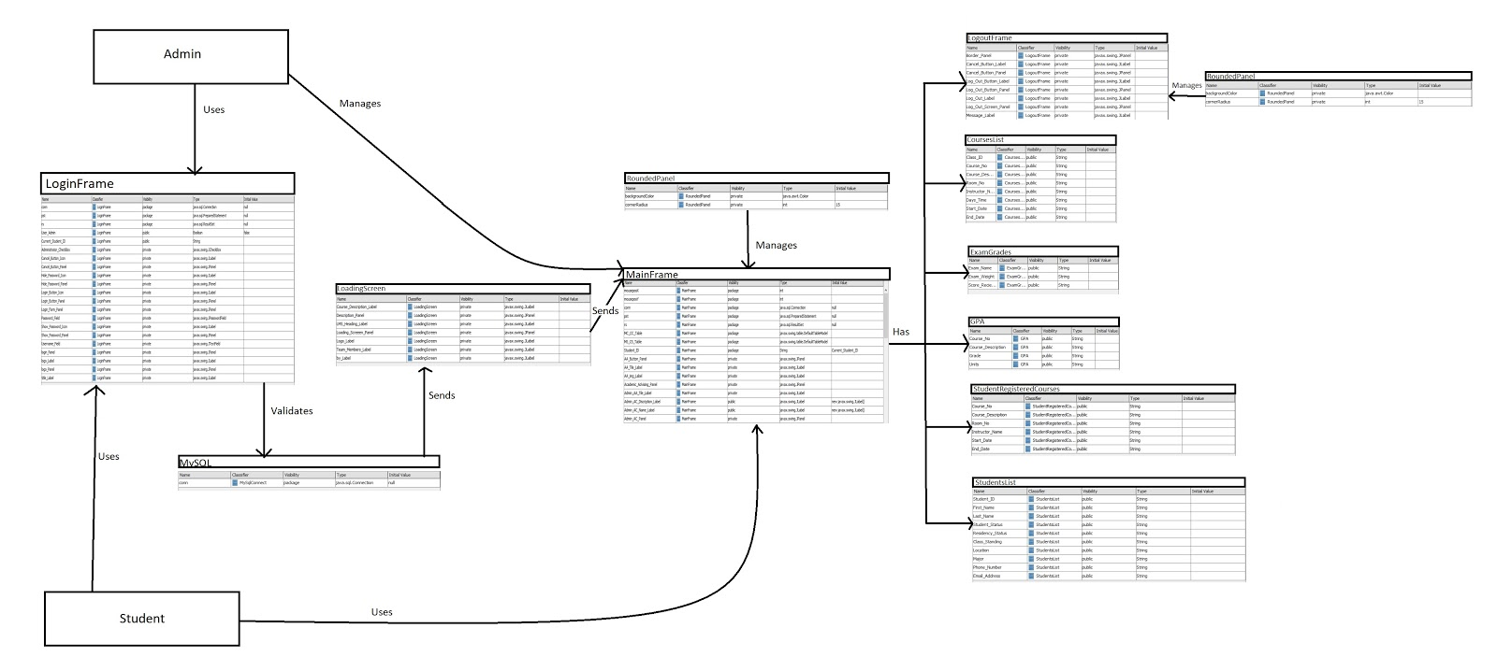

Views:

Admin: Users, attributes, all courses: Read / Write for all accounts

Student: courses, grades : Read only for specific account

Team layout

Classical Chief Programmer Team

Project Manager : Haider Qazi

Programming secretary: Christian Francois

Technical Architect: Daniel Gasperini

Programmer: David Dinh

Programmer: Javier Blanco

Vison control

GitHub: <https://github.com/pakatwood/Software-Engineering-Project>